Ip address of a domain

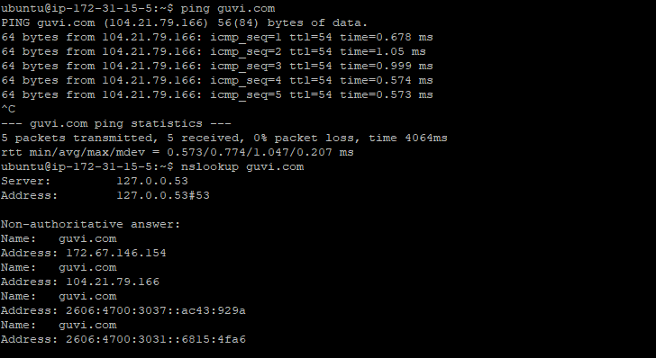

Unable to check connectivity between 2 nodes , due to issues in installing traceroute package.

Need to discuss this issues with mentor on next class.

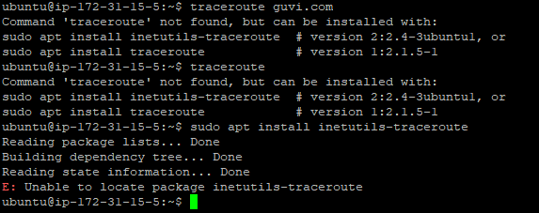

Port connectivity check

